**HDFS LAB**

man hdfs

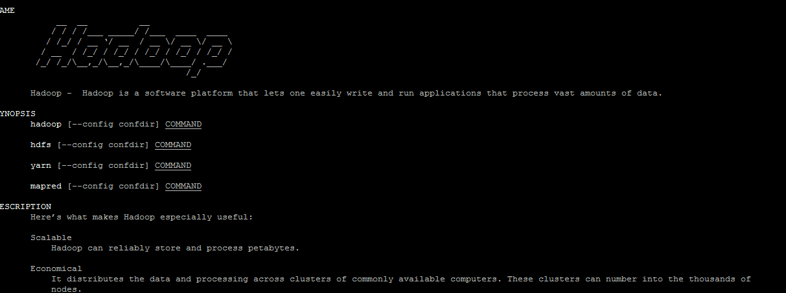

hadoop version

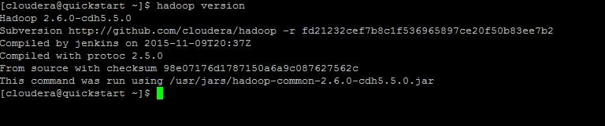

hdfs dfs –help

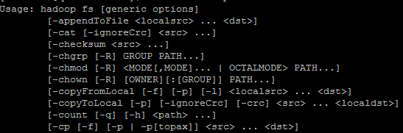

hdfs dfs -help ls

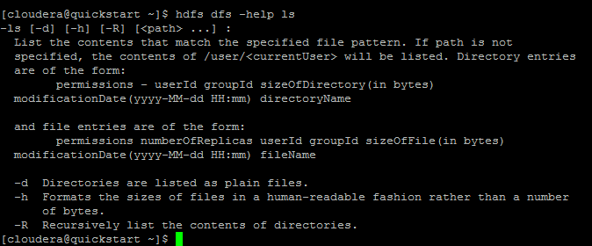

hdfs dfs –ls

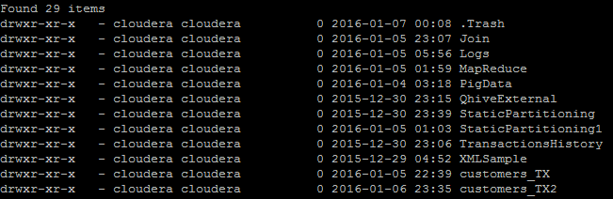

hdfs dfs -ls /

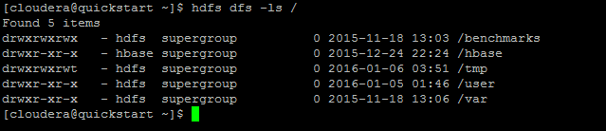

hdfs dfs -ls /user

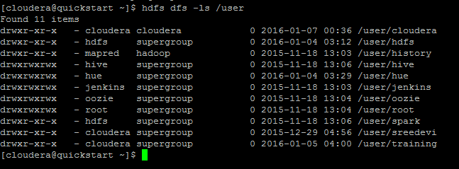

hdfs dfs -ls –R

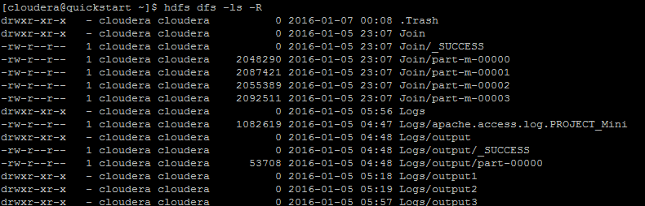

hdfs dfs –mkdir hdfsPractice

mkdir hdfsPractice

cd hdfsPractice

Use WinSCP to move data provided.

ls



cd Data

cd Logs

hdfs dfs –help

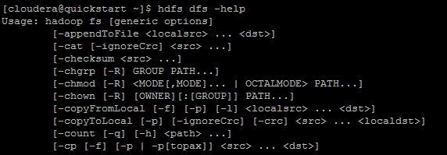

hdfs dfs -put apache.access.log.PROJECT_MinihdfsPractice

Web Interface

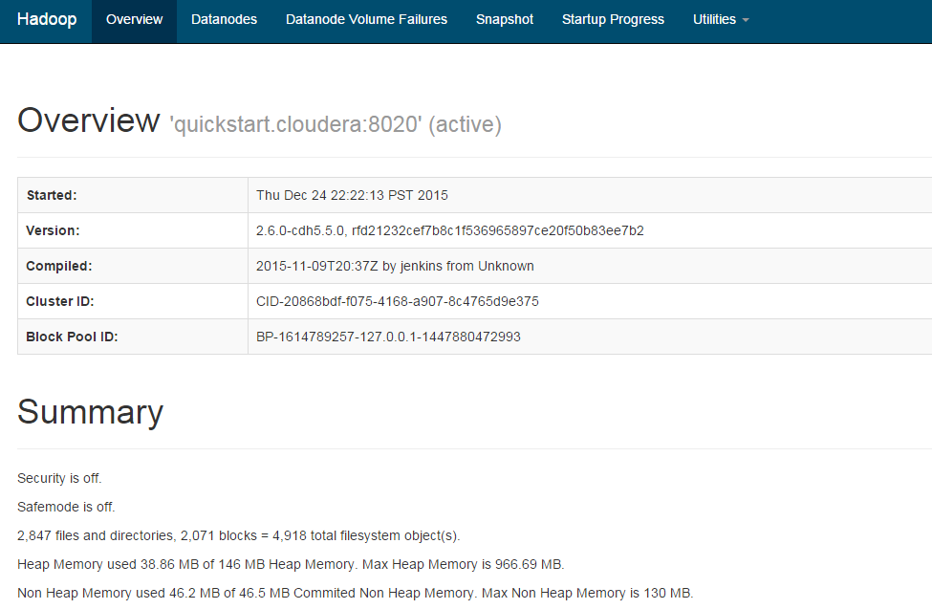

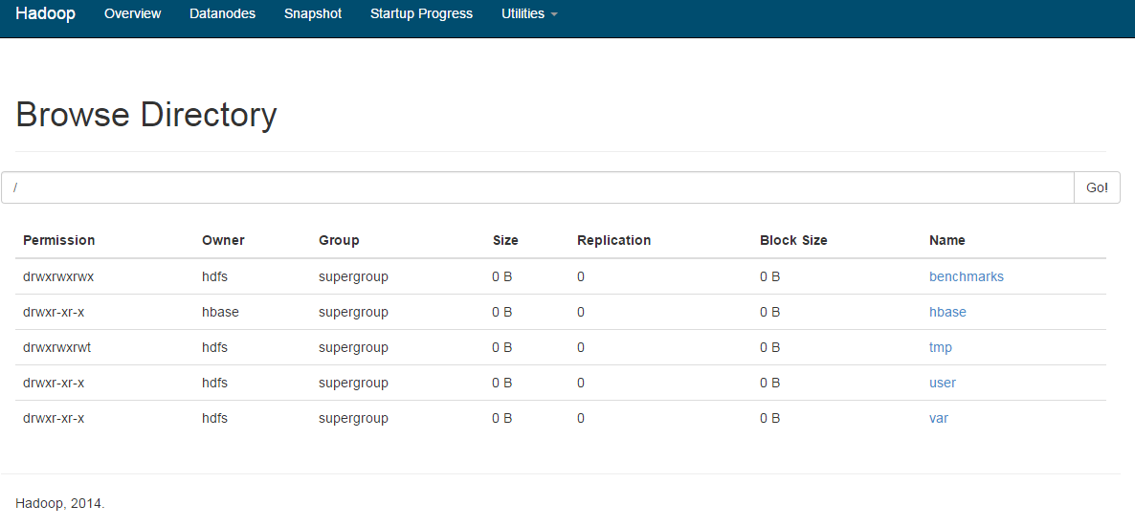

hdfs dfs -put apache.access.log.PROJECT_MinihdfsPractice



hdfs dfs -put -f apache.access.log.PROJECT_MinihdfsPractice

hdfs dfs –ls hdfsPractice



hdfs dfs -ls -h hdfsPractice

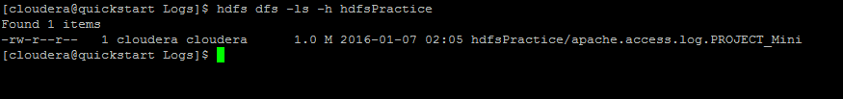

cat apache.access.log.PROJECT> apache.access.log.PROJECT.1

cat apache.access.log.PROJECT>> apache.access.log.PROJECT.1

hdfs dfs -copyFromLocal apache.access.log.PROJECT.1 hdfsPractice

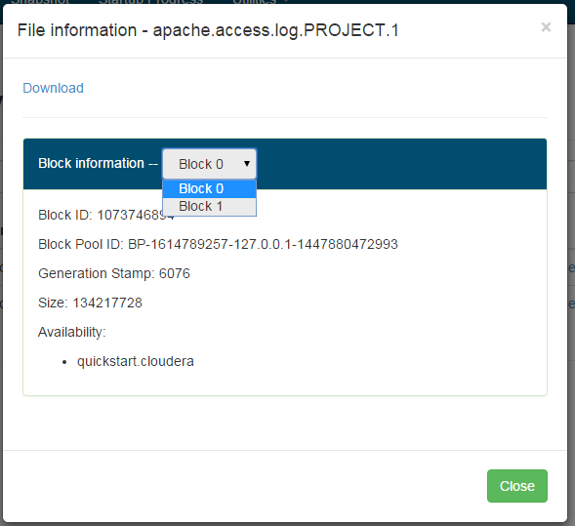

cd..

tree Transactions

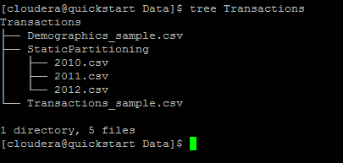

hdfs dfs -put Transactions hdfsPractice

hdfs dfs -ls -h -R hdfsPractice

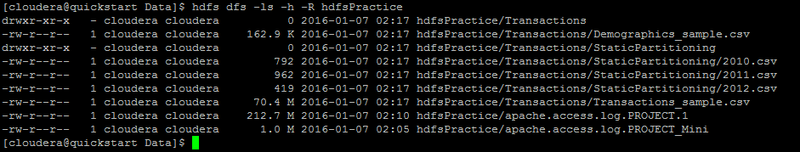

hdfs dfs -moveFromLocal Practice hdfsPractice

ls



hdfs dfs -ls -h -R hdfsPractice

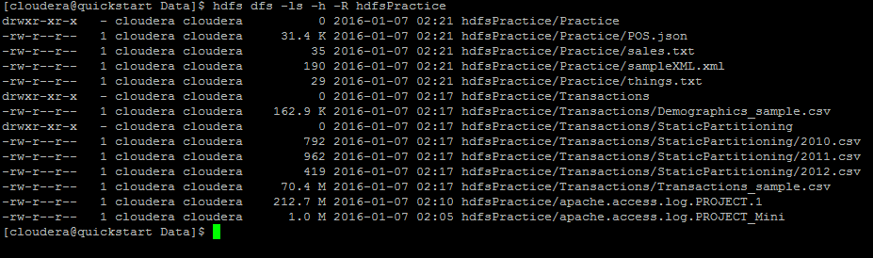

hdfs dfs -cat hdfsPractice/Transactions/Demographics_sample.csv

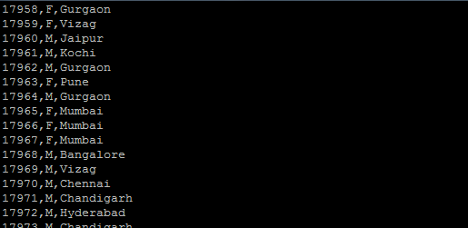

hdfs dfs -tail hdfsPractice/Transactions/Demographics_sample.csv

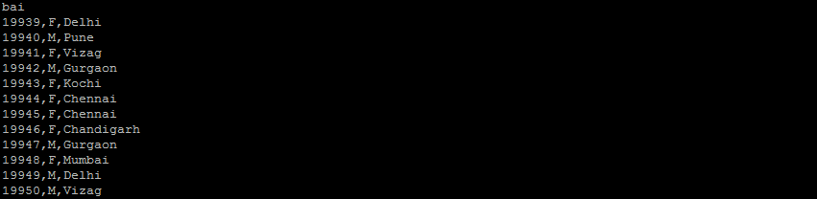

hdfs dfs -tail -f hdfsPractice/Transactions/Demographics_sample.csv

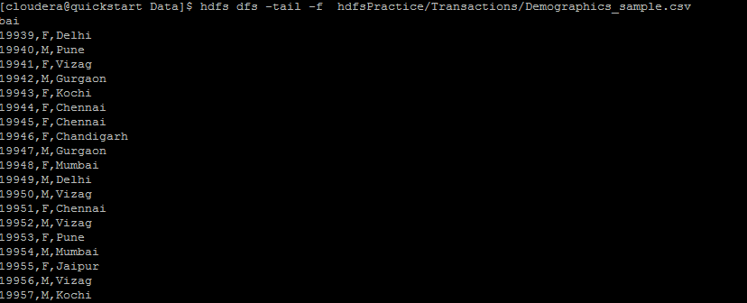

hdfs dfs -count hdfsPractice



hdfs dfs -count -h hdfsPractice



hdfs dfs -ls -h -R hdfsPractice

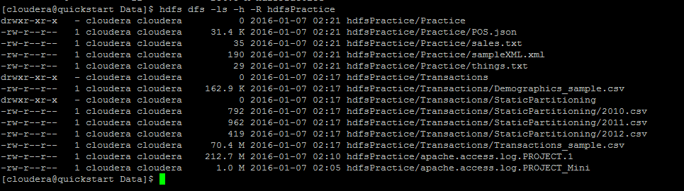

hdfs dfs –copyToLocal hdfsPractice/Practice/things.txt ./things_local.txt

hdfs dfs –copyToLocal hdfsPractice/Practice/things.txt ./things_local.txt

mkdir hdfsPracticeDownloaded

hdfs dfs -get hdfsPractice/Practice/ hdfsPracticeDownloaded

hdfs dfs –moveToLocal hdfsPractice/Practice/ hdfsPracticeDownloaded



hdfs dfs -mv hdfsPractice/Practice hdfsPractice/Practice1

hdfs dfs -ls -h -R hdfsPractice

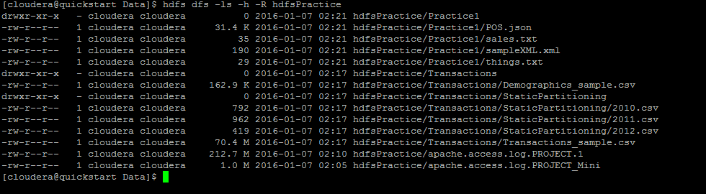

hdfs dfs –cp hdfsPractice/Practice1/POS.json hdfsPractice/Practice1/POS1.json

hdfs dfs –ls hdfsPractice/Practice1

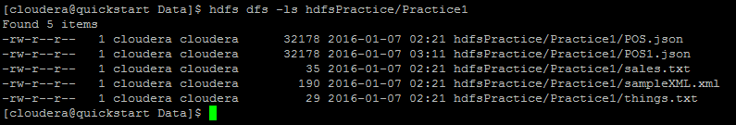

hdfs dfs –mkdir hdfsPractice/Practice2

hdfs dfs –cp hdfsPractice/Practice1 hdfsPractice/Practice2

hdfs dfs –ls hdfsPractice/Practice2

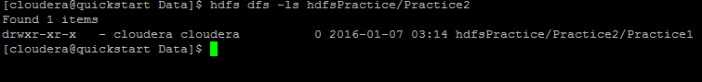

hdfs dfs –ls hdfsPractice/Practice2/Practice1

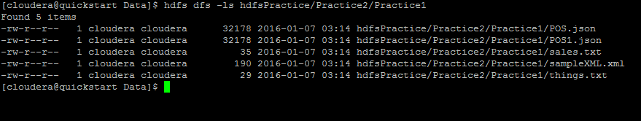

hdfs dfs -ls -h -R hdfsPractice

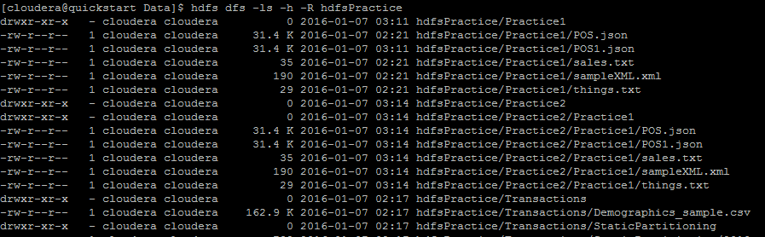

hdfs dfs -chmod 774 hdfsPractice/Practice1/POS.json

hdfs dfs -ls -h -R hdfsPractice

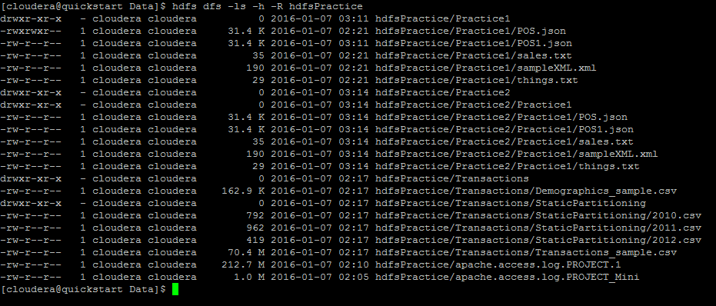

hdfs dfs -rm -skipTrash hdfsPractice/Practice1/POS1.json



hdfs dfs -ls -h -R hdfsPractice

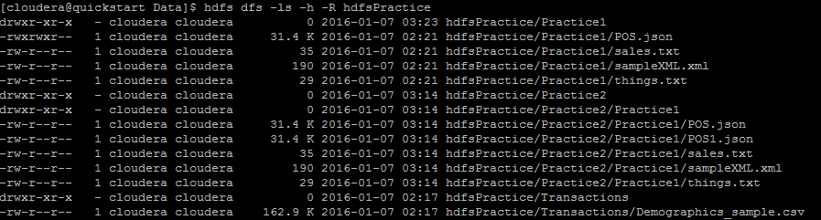

hdfs dfs -rm -r –skipTrash hdfsPractice/Practice2

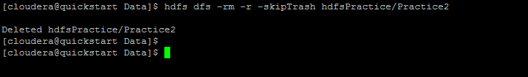

hdfs dfs -ls -h -R hdfsPractice

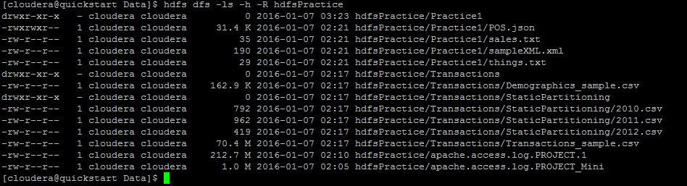

hdfs dfs -tail hdfsPractice/Practice1/sales.txt

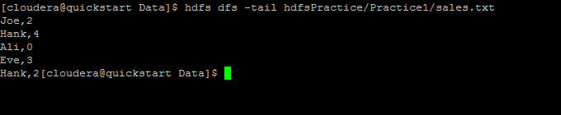

hdfs dfs -appendToFile - hdfsPractice/Practice1/sales.txt

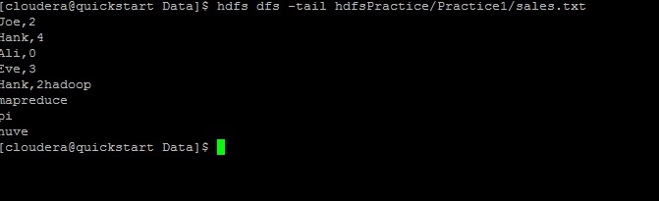

hdfs dfs -tail hdfsPractice/Practice1/sales.txt

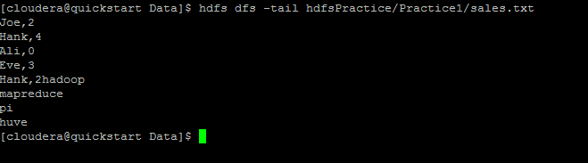

hdfs dfs -tail hdfsPractice/Practice1/sales.txt

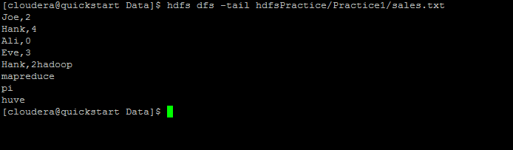

hdfs dfs -appendToFile things_local.txt hdfsPractice/Practice1/things.txt

hdfs dfs -cat hdfsPractice/Practice1/things.txt

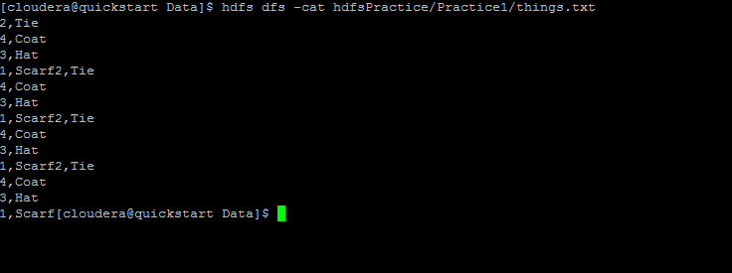

hdfs dfs –df

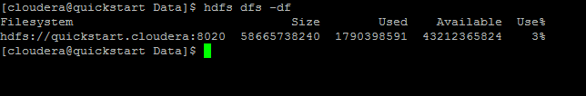

hdfs dfs -df –h

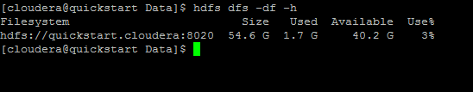

hdfs dfs -du hdfsPractice/Practice1/things.txt

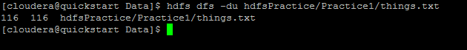

hdfs dfs –expunge



hdfs dfs -ls -h -R hdfsPractice

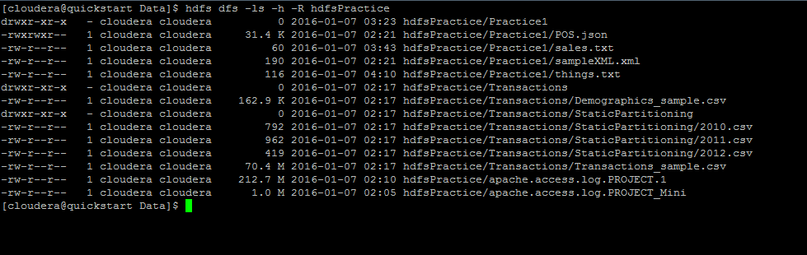

hdfs dfs –getfacl hdfsPractice

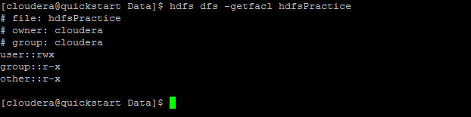

hdfs dfs -getfacl -R hdfsPractice

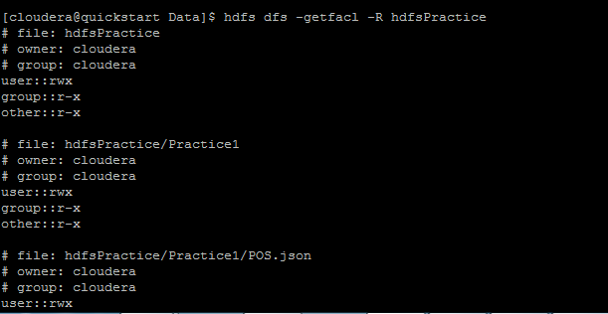

hdfs dfs -setrep 2 /user/cloudera/hdfsPractice/Transactions/Demographics_sample.csv

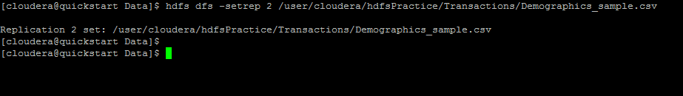

hdfs dfs -stat /user/cloudera/hdfsPractice/Transactions/Demographics_sample.csv



hdfs dfs -stat -h %b /user/cloudera/hdfsPractice/Transactions/Demographics_sample.csv

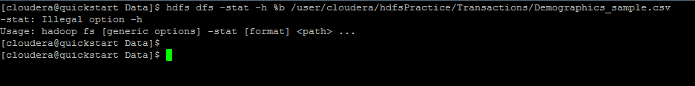

hdfs dfs -usage ls

